Show Garden Competitions 2026
Dear Applicant,
We are delighted to announce the Show Garden options for our first Hinckley BID Garden show 2026 are now OPEN!
Hinckley BID’s Garden Show will take place across two days; 16th-17th May, open time 10am-4pm (Exhibitors & Designers can be onsite from 8am)
Hinckley BID events can attract up to 27,000 people into the town centre, this new event is projected to see over 10,000 visitors over the weekend. With fresh features, inspiring experts, and a vibrant collection of each brimming with seasonal colour and creative ideas.
Who is it for?
For the professionals - Show Gardens, Serenity Spots & Patio Spaces are a fantastic way to display your skills as a garden designer and planter, displaying your business to thousands of people throughout the duration of the shows.
For gardening clubs and charities, Patio Spaces, Small spaces, Recycled Garden, Serenity Spot, Indoor planting interior design table competition is a creative and engaging way to raise awareness and convey a message to a receptive audience.
For Garden Design and Horticulture students, the small spaces offer an unbeatable chance to gain experience of designing and building a show garden.
Awards:
All entries will be assessed for a recognition Award medal, which range Platinum, Gold, Silver, there are awards for category winners who will also receive a glass trophy.
Competition categories include:
- Best Show Garden
- Best Small Space
- Best Patio Space
- Most unique Unusual Planting (Recycled item garden)
- Surenity Spot
- Indoor planting interior design table
- People’s Choice Business Garden in the Town for the show

We have fantastic judges this year: Judging is Saturday 16th May.
Sam Theakstone, owner of Samantha Jane Décor, Gardeners World Silver Merit Winner 2024, Grand design Live Public Choice winner 2020.
Trish Coggan, Grand Design Live 2018 designer, Interior design Masters series one designer.
Pete Stead-Davis , built show gardens at urbangardens, Olympia, East of England Garden Show, won a gold award, built a small garden at BBC Gardener's World Live part of which was shown on Gardener's World and finally The Sandringham Flower Show were got a silver medal.
Zoe McGrady from BBC Radio Leicester, Lives in Hinckley.

Theme: Living
Are you ready for a new challenge? We are seeking talented individuals who will go on to be part of the inspirational first ever Garden Show in Hinckley Town Centre 2026. By designing a Show Garden, Small Space, Patio Space, Unusual Planting (Recycled Item Garden) or a Serenity spot, Indoor planting interior design table.
Horticulture students, landscapers, community groups, and charities have the chance to create an inspiring garden space on the theme of ‘Living’.
This theme invites you to discover how even the smallest garden can become a great space to relax, tell your story, memories to moments, and dreams to reality. Through plants, colour, and design, your area can transport visitors into a world where imagination gives other creativity and ideas. You can never be too wild.
Our Patio spaces or Serenity Spots offer big inspiration in small spaces—perfect for budding gardeners, urban plot owners, or anyone looking to transform a corner of their world into something magical. Using clever planting techniques, upcycled materials, and your own creative flair, show our visitors how a small area can spark big ideas.
Indoor planting interior design table ideal for anyone who fancies getting creative.
Whether your space reflects cherished memories, personal milestones, or creative dreams, we invite you to dig deep, be bold, and let your imagination bloom.
Let your design begin and end with a burst of inspiration for every visitor who sees it.

Apply now!
Applying is quick and easy, please complete the attached application. Should you have any questions or issues regarding the application, please feel free to get in touch. info@hinckleybid.co.uk
Once we have received your application for our Garden Show 2026, we will endeavour to get back to you within 14 days of receiving your application, we will be reviewing all applications after the application deadline of 20th Feb.

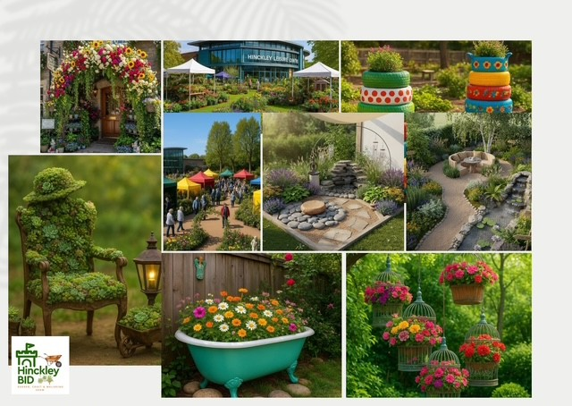

Show Gardens 2026
Please complete the below form and return as soon as possible to Helen by email info@hinckleybid.co.uk
Allocation of space will be confirmed within 21 days of receipt of application and successful applicants will be allocated space by 28th February.
Please make sure your completed form is returned with the below documents:
​​☐​ Scale plan view drawing
​​☐​ Perspective drawing (This can be isometric, oblique, or axonometric. It can also be a freehand sketch. For PR purposes, this is the most important view as we will wish to include it on our web site. A coloured and high-resolution version is always more impressive.) or Mood board.
​​☐​ one hundred–150-word description for use in the Show guide, on-site signage, and PR purposes
​​☐​ Preliminary planting plan with key structural specimens
​​☐​ Any other relevant details for example, sculpture, water etc.

APPLYING FOR THESE CREATIVE DESIGNS
Please tick a box

​​☐​ Small Spaces 1metre x 1metre

​​☐​ Patio Spaces 2metre x 1metre

☐​ Unusual Planting (Recycle Item Garden) you provide the full feature to go within our Flourish Field
​​
☐​ Surenity Spot, creative design to relax and enjoy escape.
​​
☐​ Indoor planting interior design table this will be a furniture area 1.5mx1.5m indoors where Pieces of Furniture are used with Floral of plants.
​​
☐​ Best creative look Business in town for the show., BID Business entering their business space, doorway, or front.

Timeline: send Application in and design drawn, professionally or mood board for visual understanding by the 20^{th of} February, create on site 14th & 15th May to be judged Saturday 16th May and pack down 4pm-7pm Sunday 17th May

CONTACT DETAILS
Exhibitor Contact Details
These details are used for communication between the Show Team and the Exhibitor and will not be published:

Company (if applicable)
Key Contact
Address
Post Code
Email
Telephone | Mobile | Landline
Web Address
 | ​​☐​ Yes ​☐​ No
Social Media Handles (as applicable) | Facebook:  Instagram:

Design Details
Designer’s Name
Company/Organisation/College
(if applicable)
Title of area
The theme for 2026 will be:
Living

Please write a short story or design explanation (100-150 words) for marketing
Please use a separate sheet if necessary.

Please send logos if you have them.
FINAL CHECKLIST
Here is a final summary of the actions you need to take and all forms that need to be completed with your application, before sending this form and associated documents to helen@hinckleybid.co.uk
- Have you completed all relevant parts of this form?
- Have you enclosed all the documents outlined within this application asked for like designs visuals?
- Saved a copy of these files for your own reference?

On acceptance of application, detailed requirements along with an outline of the rules and regulations will be discussed.
In submitting this application, I/we confirm that if this application is successful I/we will comply with the schedule set out in by Hinckley BID and have read and understood all enclosed documents.

Signed: _________________________________________
Date: _____________

